# How to use JSOM to change a user's permissions on lists and libraries in SharePoint (SPSChangeUserListPermission)

## Introduction

This sample demonstrates how to use JavaScript Object Model to change user permission on list or library.

## Running the Sample

1. Open the project by double-clicking the SPSChangeUserListPermission.sln.
2. Locate the CSSPSChangeUserListPermission folders under the Layouts folder. Open the ChangePermissions.aspx page. In the CustomPermission function, **modify the following variables to yours**: list name (RatingList in this sample), username (domain\username) and the RoleType (**SP.RoleType.contributor** in this sample).
3. In the Solution Explorer window, right-click the project name and then click Deploy.
4. View the ChangePermissions page in the web browser. The link resembles the following:

**Yoursite/_layouts/15/CSSPSChangeUserListPermission/changepermissions.aspx**.

**Before** running the changepermissions page, we will have list permissions as shown below:

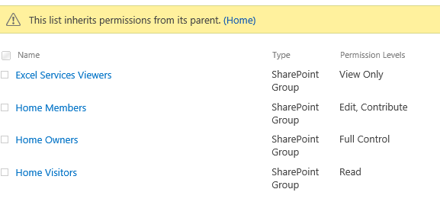

**After** running the changepermissions page, we will get list permissions of new levels as shown below:

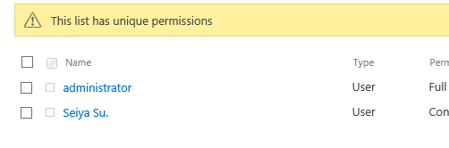

1. Validation is finished.

## Using the Code

1. Start **Visual Studio**.
2. On the **File** menu, click **New**, and then click **Project**.
3. In the Installed Templates section of the **New** **Project** dialog box, expand either Visual Basic or Visual C#, expand **SharePoint**, and then click **Empty SharePoint Project**.
4. Right-click the project to add the desired folder.

"**Add**" >>"**SharePoint Layouts Mapped Folder**".

1. Right-click the "**Layouts**" folder then add a new folder named "ChangeUserListPermission", then add a new Page named "ChangePermissions.aspx".
2. Add references to relevant JavaScript files to the page:

|  |
| --- |
| -Code block start-  --HTML code snippet start--  <script type="text/javascript" src="jquery-1.9.1.min.js"></script>  <script type="text/javascript" src="/_layouts/15/sp.runtime.js"></script>  <script type="text/javascript" src="/_layouts/15/sp.js"></script>  <% #if SOME_UNDEFINED_CONSTANT %>  <script type="text/ecmascript" src="/_layouts/SP.core.debug.js" ></script>  <script type="text/ecmascript" src="/_layouts/SP.runtime.debug.js" ></script>  <script type="text/ecmascript" src="/_layouts/SP.debug.js" ></script>  <% #endif %>  --HTML code snippet end--  Insert other Programming Language Code Snippet here  -Code block end- |

1. And then use the following script to handle the operation:

|  |
| --- |
| -Code block start-  --JavaScript code snippet start--  <script type="text/javascript">  $(document).ready(function () {  // Call the function.  CustomPermission();  });  // Web of current client context.  var web;  // The list\Library will be operation.  var oList;  // The user will be operation.  var oUser;  // The roles will be operation.  var roles;  function CustomPermission() {  // Get current client context.  var clientContext = new SP.ClientContext.get_current();  // Get current web.  this.web = clientContext.get_web();  // Provide the existing list name.  this.oList = this.web.get_lists().getByTitle('RatingList');  // Break the inheritance.  this.oList.breakRoleInheritance(false, true);  // Get the user(domain\username).  this.oUser = this.web.ensureUser("seiyasu\\seiya");  // Define the roles that will be operation.  this.roles = SP.RoleDefinitionBindingCollection.newObject(clientContext);  this.roles.add(web.get_roleDefinitions().getByType(SP.RoleType.contributor));  // Register the role for the user.  this.oList.get_roleAssignments().add(this.oUser, this.roles)  clientContext.load(this.web);  clientContext.load(this.oUser);  clientContext.load(this.oList);  //Make a query call to execute the above statements  clientContext.executeQueryAsync(Function.createDelegate(this, this.onQuerySuccess),  Function.createDelegate(this, this.onQueryFailure));  }    function onQuerySuccess() {  $('#message').text('Updated');  }  function onQueryFailure(sender, args) {  alert('Request failed. ' + args.get_message() + '\n' + args.get_stackTrace());  }  </script>  --JavaScript code snippet end--  Insert other Programming Language Code Snippet here  -Code block end- |

1. Now you can build and debug it.

## More Information

SharePoint 2013 .NET Server, CSOM, JSOM, and REST API index  
<http://msdn.microsoft.com/en-us/library/office/dn268594(v=office.15).aspx>  
How to: Add and Remove Mapped Folders  
<http://msdn.microsoft.com/en-us/library/ee231521.aspx>  
SP.ClientContext Class  
<http://msdn.microsoft.com/en-us/library/office/ff408569(v=office.14).aspx>  
SPRoleType enumeration  
<http://msdn.microsoft.com/en-us/library/microsoft.sharepoint.sproletype.aspx>  
SP.RoleDefinitionBindingCollection Class  
<http://msdn.microsoft.com/en-us/library/office/ff410029(v=office.14).aspx>  
How to: Work with Roles Using JavaScript  
<http://msdn.microsoft.com/en-us/library/office/hh185014(v=office.14).aspx>  
SPRoleDefinitionCollection class  
<http://msdn.microsoft.com/en-us/library/office/microsoft.sharepoint.sproledefinitioncollection(v=office.15).aspx>